# Problem #1 - SQL

Given the following tables…

PERSON

-----------------------------------

PK person_id NUMBER(10) NOT NULL

first_name VARCHAR2(100)

preferred_first_name VARCHAR2(100)

last_name VARCHAR2(100) NOT NULL

date_of_birth DATE

hire_date DATE

occupation VARCHAR2(1)

ADDRESS

-----------------------------------

PK address_id NUMBER(10) NOT NULL

FK person_id NUMBER(10) NOT NULL

address_type VARCHAR2(4) NOT NULL

street_line_1 VARCHAR2(100)

city VARCHAR2(100)

state VARCHAR2(100)

zip_code VARCHAR2(30)

I have created PERSON and ADDRESS tables and inserted few sample records using w3schools SQL Editor.

/* Create a table called PERSON */

create table PERSON (

person_id NUMBER(10) NOT NULL PRIMARY KEY,

first_name VARCHAR2(100),

preferred_first_name VARCHAR2(100),

last_name VARCHAR2(100) NOT NULL,

date_of_birth DATE,

hire_date DATE,

occupation VARCHAR2(1)

);

/* Create a table called ADDRESS */

create table ADDRESS (

address_id NUMBER(10) NOT NULL,

person_id NUMBER(10) NOT NULL,

address_type VARCHAR2(4) NOT NULL,

street_line_1 VARCHAR2(100),

city VARCHAR2(100),

state VARCHAR2(100),

zip_code VARCHAR2(30),

PRIMARY KEY (address_id),

FOREIGN KEY (person_id) REFERENCES Person(person_id)

);

/* Insert few records in PERSON table */

insert into person values(1,'suresh reddy','suresh','singireddy','1992-06-05','2019-01-17','Software Developer');

insert into person values(2,'samul','sam','adam','1989-11-01','2018-01-11',NULL);

insert into person values(3,'mark','mark','randy','1990-05-11','2018-01-12','Analyst');

insert into person values(4,'Tom',null,'Bruce','1988-02-01','2019-01-01','Tech Lead');

/* Insert few records in ADDRESS table */

insert into address values (1,1,'HOME','89 Lyon Circle','Clifton', 'VA','12345');

insert into address values (2,2,'HOME','212 Maple Ave','Manassas', 'VA','22033');

insert into address values (3,1,'BILL','25 Science Park','New Haven', 'CT','06511');

insert into address values (4,2,'BILL','275 Winchester Ave','New Haven', 'CT','06511');

insert into address values (5,3,'HOME','9405 White Cedar Dr','Owings Mills', 'MA','21117');

/* Display all the records from PERSON table */

SELECT * FROM PERSON;

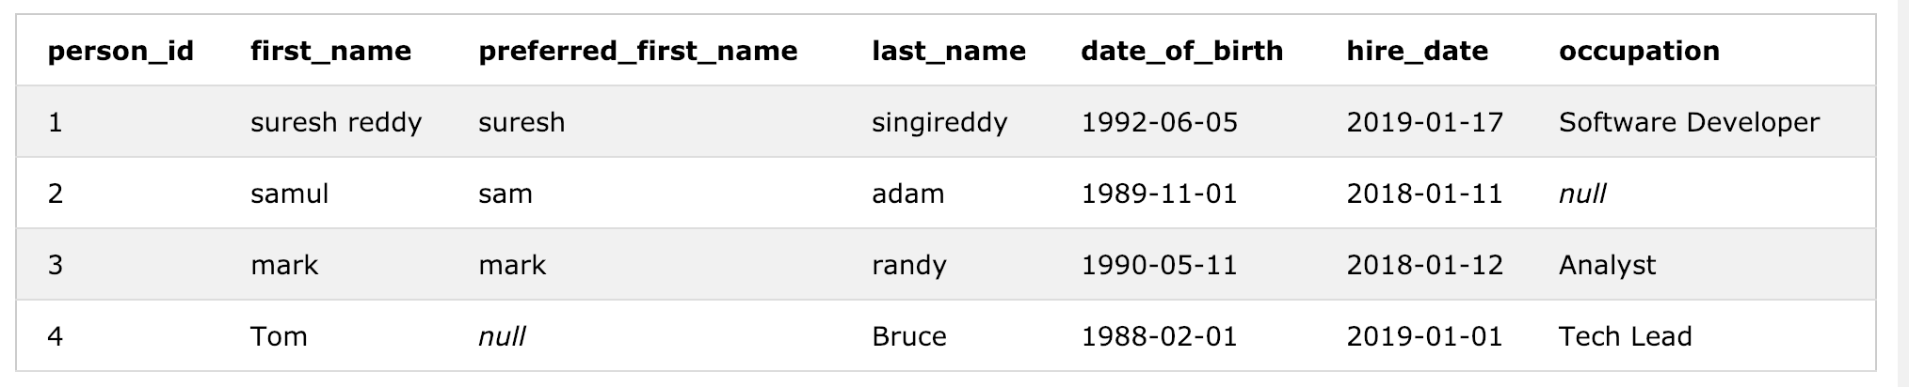

/* Display all the records from ADDRESS table */

SELECT * FROM ADDRESS;

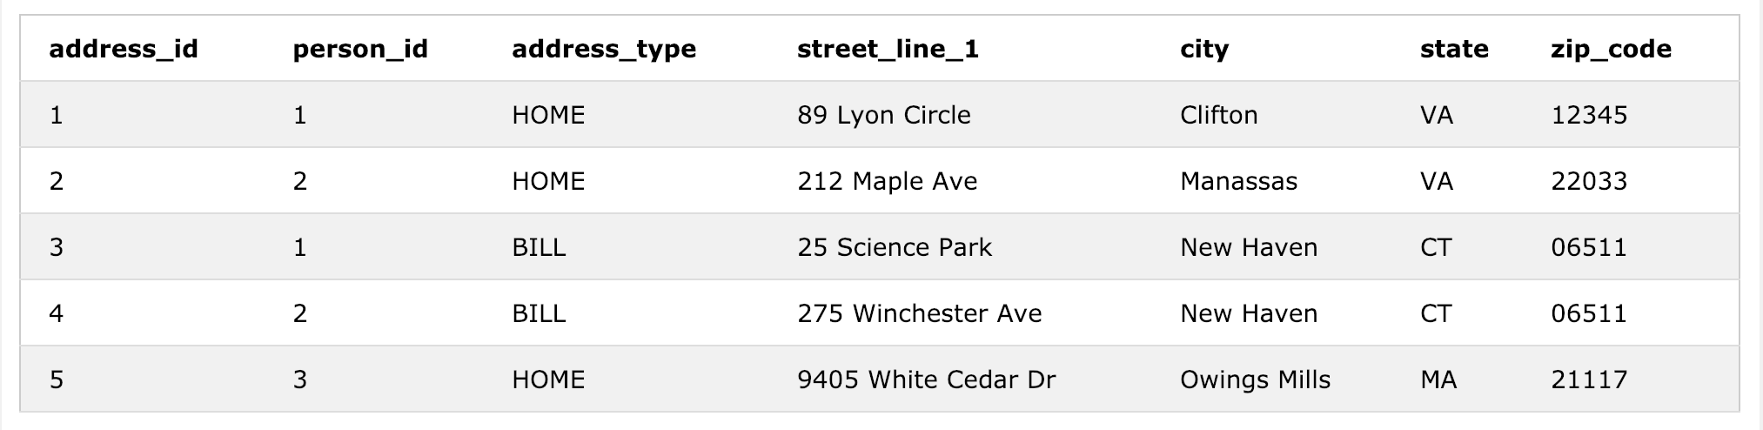

1. Write a query to select all rows from *person*. If the person row has a value in *preferred_first_name*, select the preferred name instead of the value in *first name*. Alias the column as *REPORTING_NAME*.

SELECT

CASE WHEN preferred_first_name IS NOT NULL

THEN preferred_first_name

ELSE first_name

END AS REPORTING_NAME

FROM PERSON;

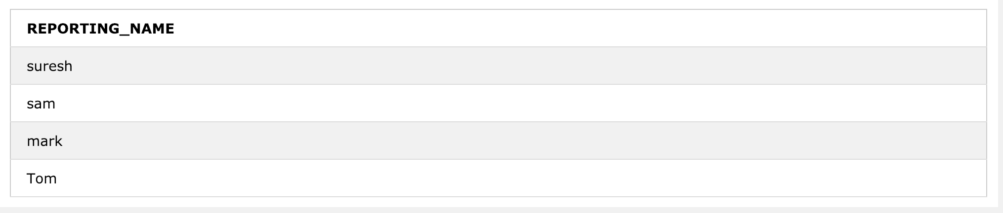

1. Write a query to select all rows from person that have a NULL occupation.

SELECT * FROM person WHERE occupation IS NULL;



1. Write a query to select all rows from *person* that have a *date_of_birth* before August 7th, 1990.

SELECT * FROM person WHERE date_of_birth <'1990-08-07';

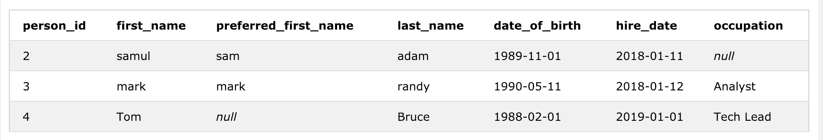

1. Write a query to select all rows from *person* that have a *hire_date* in the past 100 days.

SELECT * FROM PERSON WHERE HIRE_DATE >= DATE('now','-100 day');

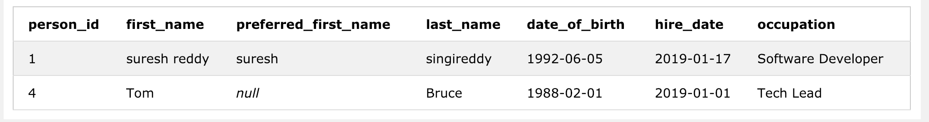

1. Write a query to select rows from person that also have a row in address with address_type = 'HOME'

Select * From PERSON P JOIN ADDRESS A ON P.person_id=A.person_id WHERE a.address_type='HOME';

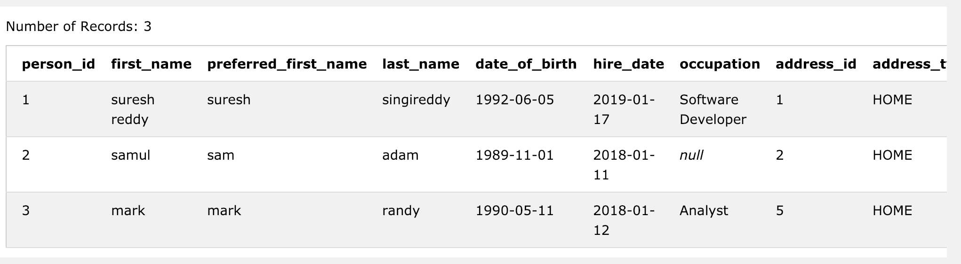

1. Write a query to select all rows from person and only those rows from address that have a matching billing address (address_type = 'BILL'). If a matching billing address does not exist, display 'NONE' in the address_type column.

SELECT P.*, CASE WHEN A. address_type IS NULL

THEN 'NONE' ELSE address_type END AS address_type

FROM PERSON P LEFT OUTER JOIN ADDRESS A ON P.person_id=A.person_id AND a. address_type = 'BILL';

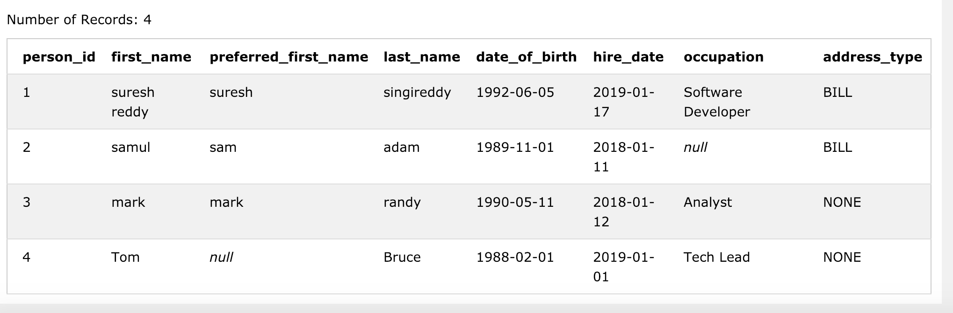

1. Write a query to count the number of addresses per address type.

Output:

**address_type count**

------------- ------

HOME 99

BILL 150

SELECT address_type, COUNT(*) AS count FROM ADDRESS GROUP BY address_type;

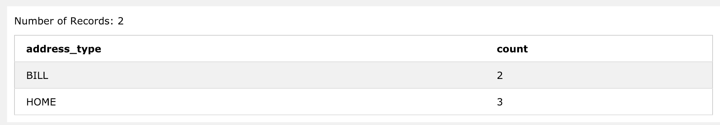

1. Write a query to select data in the following format:

**last_name home_address billing_address**

------------------ ------------------------------------ ---------------------------------------

Smith 89 Lyon Circle, Clifton, VA 12345 25 Science Park, New Haven, CT 06511

Jones 212 Maple Ave, Manassas, VA 22033 275 Winchester Ave, New Haven, CT 06511

/*using joins */

SELECT p.last_name,

CASE WHEN a.ADDRESS_type='HOME' THEN a.street_line_1||','||a.city||','||a.state||','||a.zip_code END

AS home_address,

CASE WHEN b.ADDRESS_type='BILL' THEN b.street_line_1||','||b.city||','||b.state||','||b.zip_code END

AS billing_address

FROM person p JOIN address a ON p.person_id=a.person_id

JOIN address b ON a.person_id=b.person_id

WHERE a.ADDRESS_type='HOME' AND b.ADDRESS_type='BILL'

GROUP BY a.person_id

/* using CTE */

WITH adress_value AS (

SELECT a.person_Id,

CASE WHEN a.ADDRESS_type='HOME' THEN a.street_line_1||','||a.city||','||a.state||','||a.zip_code

END AS home_address ,

CASE WHEN b.ADDRESS_type='BILL' THEN b.street_line_1||','||b.city||','||b.state||','||b.zip_code

END AS billing_address

FROM address a JOIN address b ON a.person_id=b.person_id WHERE a.ADDRESS_type='HOME' AND b.ADDRESS_type='BILL'

GROUP BY a.person_Id )

SELECT p.last_name, a.home_address,a.billing_address FROM person p JOIN adress_value a ON a.person_id=p.person_id;

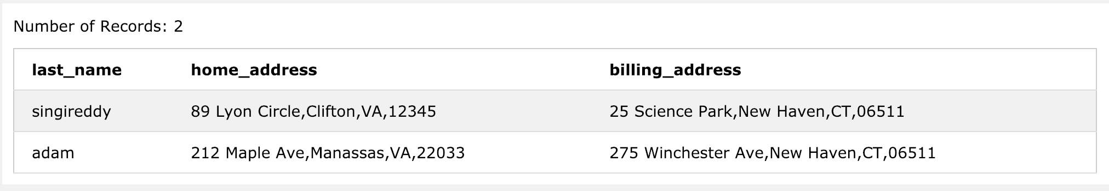

1. Write a query to update the person.occupation column to ‘X’ for all rows that have a ‘BILL’ address in the address table.

UPDATE person

SET occupation='X'

WHERE person_id IN (SELECT person_id FROM address WHERE address_type='BILL');



Before Update:

SELECT * FROM PERSON;



After Update:

SELECT * FROM PERSON;

